OOP-LAB Task 1

Roll No: 24P-0706 | Dept: BS-CS
Name: Aazan Noor Khuwaja | Section : 2D

Qns1:
#include <iostream>
using namespace std;
int main ()
{
int arr[5];
int *ptr;
ptr=arr;
for(int i=0;i<5;i++)
{
*(ptr+i)=i+1;
}
for(int i=0;i<5;i++)
{
cout <<"The values of arrray are:"<< *(ptr+i)<<endl;
}
for(int i=0;i<5;i++)
{
*(ptr+i)=5-i;
cout <<"The Reversed values of arrray are:"<< *(ptr+i)<<endl;
}
return 0;
}

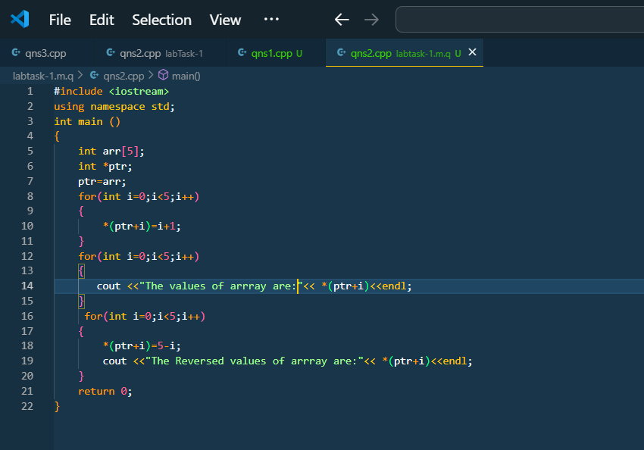
Figure 1Code
Output:
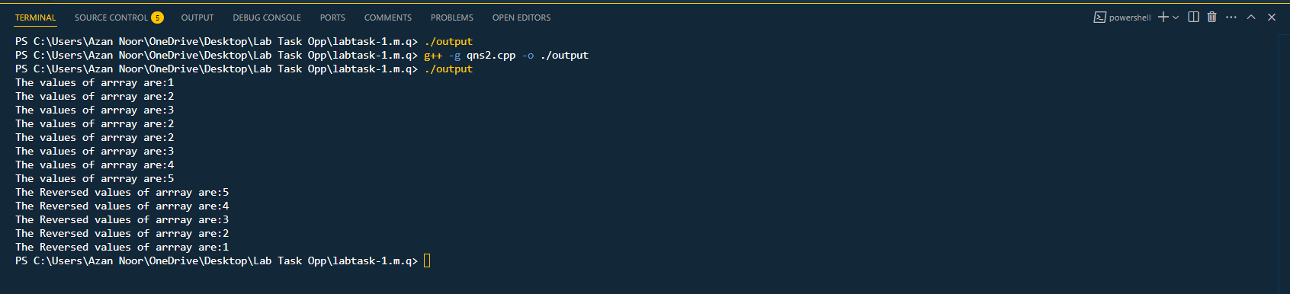
Qns 1:
#include<iostream>
using namespace std;
void turns_one_other(int *c, int *d)
{
int temp=*c;
*c=*d;
*d=temp;
}
int main()
{
int a=5,b=10;
int *p=&a,*p2=&b;
turns_one_other(p,p2);
cout<<"The Vale of a and b after swaping is :"<<*p<<" and "<<*p2<<endl;
}

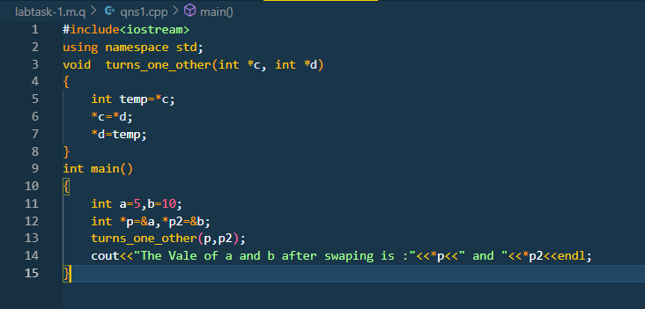

Output:
